Company Description
Apex Global Industries is a leading enterprise currently facing workforce stability challenges. Despite maintaining a robust team of highly skilled professionals, the organization has noticed an alarming increase in employee turnover, particularly among its hardest workers. The executive team urgently needs data-driven insights to understand why top talent is leaving, how much it is costing the business, and what structural changes are required to retain their best people.
Problem Statement
Conduct an Effort-Reward Imbalance (ERI) analysis to measure the impact of high-fatigue indicators (Overtime, Frequent Travel, Long Commutes) against compensation metrics (Salary Hikes, Promotion Velocity). The goal is to identify burnout-driven flight risks and recommend a restructured compensation policy that fairly rewards high-effort employees and reduces the critical 30% overtime attrition rate.

Part 1: The Baseline Profile
Q1: What is the average Monthly Income, Performance Rating, and overall Attrition Rate for each Department?
Q2: On average, how many years does an employee spend in their current role, and at the company overall?

Part 2: The Effort & Burnout Indicators
Q3: Do employees who have high distance from home or frequent travel report lower Work-Life Balance scores?
Q4: What percentage of our workforce is currently working Overtime, and which department relies on Overtime the most?

Part 3: The Reward Disconnect
Q5: Do employees who work Overtime actually receive a higher Monthly Income or a higher percentage Salary Hike than those who do not?
Q6: Do employees who stay loyal to the company for 5+ years receive higher performance ratings and salary hikes, or do they stagnate compared to newer employees?

Part 4: The Flight Risk
Q7: Is the company relying on top-performers who have terrible Work-Life Balance? If so, what is their Attrition rate?
Q8: When an employee is in the "High Effort" bucket (Overtime = Yes) but the "Low Reward" bucket (Low Salary Hike), how much higher is their Attrition Rate compared to the rest of the company? Which department is bleeding the most talent because of this?Executive Summary
Apex Global Industries is currently facing a critical retention crisis, but it is not a general problem—it is highly targeted. After analysing our employee data, it is clear that we are not losing our underperformers. Instead, our current compensation and cultural structures are actively burning out and driving away our most elite, hard-working talent.
Below is a breakdown of the four major hidden risks causing our top employees to quit, and exactly where we need to take action.
1. The Flight Risk: We Are Burning Out Our Best People
When we looked at our "Outstanding" employees (Top Performers) who also reported having a terrible Work-Life Balance, the numbers were alarming.
- The Finding: Top performers with bad work-life balance are quitting at a massive rate of nearly 36%.
- The Comparison: When top performers have a healthy work-life balance, their quit rate drops down to just 13%.
- What this means: We are leaning too heavily on our most talented people without giving them time to recover. We are fundamentally
- burning out our most valuable talent, and they are leaving for our competitors.
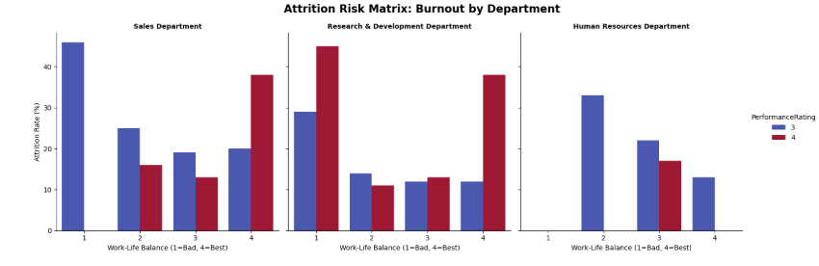

2. The "High Effort, Low Reward" Trap (The Sales Crisis)
We investigated the relationship between the extra hours employees put in (Overtime) and how they are rewarded during performance reviews (Salary Hikes).
- The Finding: We isolated a group of employees who are putting in maximum effort (working overtime) but receiving minimum financial reward (raises of 14% or less).
- The Impact: This "High Effort, Low Reward" group is quitting at a catastrophic rate, specifically within the Sales Department, where attrition spikes dramatically compared to the rest of the team.
- What this means: We are asking employees to sacrifice their personal time for the company, but failing to compensate them for that sacrifice.
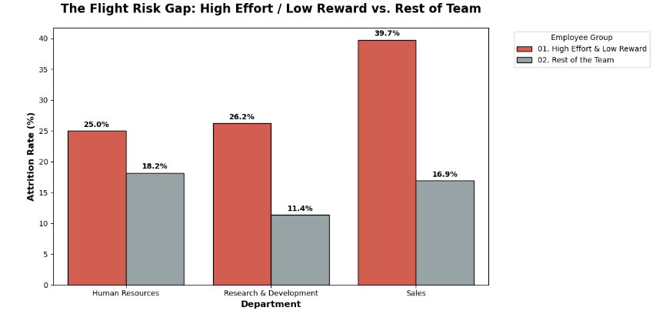

3. The "Loyalty Penalty"
We looked at what happens to an employee's compensation the longer they stay with the company.
- The Finding: There is a clear downward trend showing that as an employee’s tenure increases, their average percentage salary raise actually decreases.
- What this means: Financially, it pays to be a new hire, but it hurts to be a veteran. By giving smaller percentage raises to our most loyal employees, we are accidentally incentivizing our most experienced staff to leave and get a larger pay bump elsewhere.

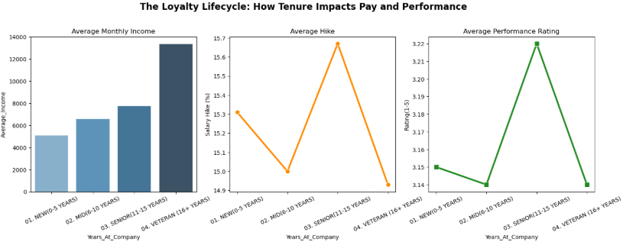

4. The Grade Inflation Problem
While investigating performance, we discovered a major flaw in how managers are reviewing their teams.
- The Finding: 100% of the employees in the company are rated as either a "3 - Excellent" or a "4 - Outstanding." There is not a single employee rated as a 1 or a 2.
- What this means: Because managers are refusing to give honest, critical ratings, our performance review system is essentially broken. It makes it extremely difficult for HR to identify actual underperformers and reward true top-tier talent.
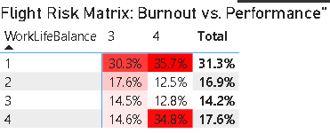

Strategic Recommendations
To stop the bleeding of our top talent, we recommend the following immediate actions:
- Audit Overtime in the Sales Department: Immediately investigate why Sales requires so much unpaid overtime and adjust staffing or compensation to balance the load.
- Revamp the Raise Structure: Implement a policy to ensure that employees working consistent overtime receive proportionate salary hikes (>15%) to eliminate the "High Effort, Low Reward" trap.
- Correct the Loyalty Penalty: Review the compensation of employees who have been with the company for more than 5 years to ensure their raises remain competitive with market rates, preventing them from jumping ship for better pay.
- Mandate Honest Performance Reviews: Train managers on proper evaluation metrics so that a "3" or "4" rating actually means something, allowing us to truly identify and protect our best people.

